|  |
| --- |
| evil family game studios |
| Mail Pilot |
| **retro shooter** |
| Version #01  All work Copyright © 2012 by Evil Family Game Studios.  All rights reserved. |
| **Julian Giraldo** |
|  |

**Insert a Company Logo here**

|  |
| --- |
| September 24th 2016 |

**Table of Contents**

[Your Table of Contents should go here. Make sure that your document’s sections are hyperlinked to their corresponding pages.]

**Version History**

<https://github.com/judagiro/Comp305-f2016>

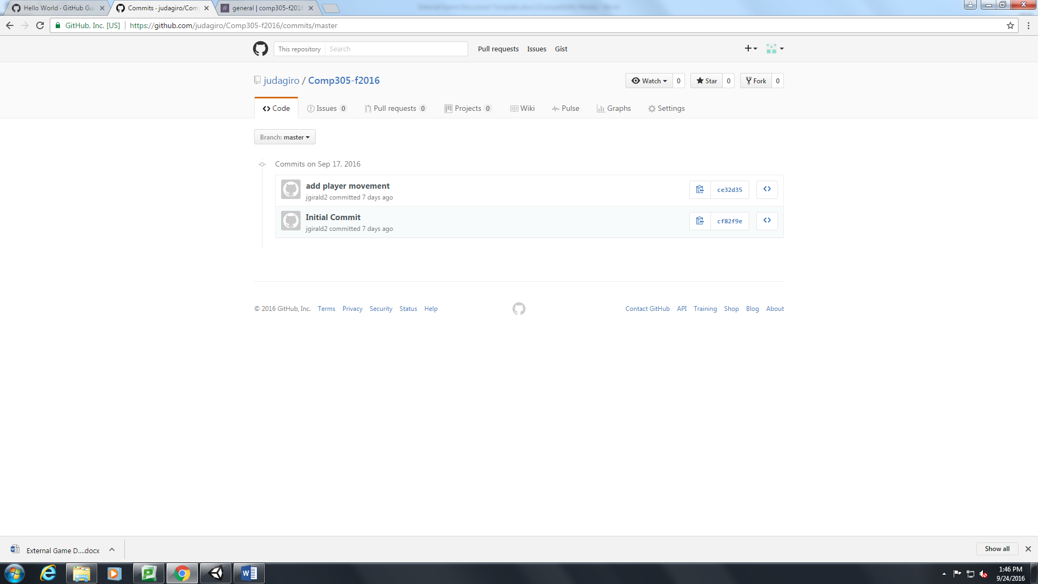

[This is the body of your video game design document. You should add and delete sections as they pertain to your game’s design.]

1. **Game Overview**

*(ensure you mention the goal of the game and how to win if applicable)*

*Mail Pilot is a simple retro side-scrolling shooter game. The player’s plane is limited to the bottom portion of the screen and can only move side to side.*

1. **Game Play Mechanics**

*(how does your game work?)*

1. **Camera**

*(Point of View)*

*The camera for this game uses on orthographic projection from a top-down(birds-eye) view.*

1. **Controls**

*(Which keys does your game use? Does it use the mouse or a joystick?)*

*The controls for this game*

1. **Saving and Loading**

*(Does your game include saving and loading? When? How?)*

1. **Interface Sketch**

*(What does the game interface look like? Provide a screen shot or sketch)*

1. **Menu and Screen Descriptions**

*(Include additional screen shots and accompanying descriptions for any menus and additional screen)*

1. **Game World**

*(Describe Your Game Environment)don’t do this point.*

1. **Levels**

*(Describe Each of your game levels)*

1. **Game Progression**
2. **Characters**

*(Describe Your game avatar if applicable)*

*The player’s avatar is a simple bi-plane that seems to fly over a scrolling ocean. The player’s movement is limited (right-to-left only) to increase the challenge level of the game.*

1. **Non-player Characters**

(Describe Any Computer controlled Allies and how they work)

1. **Enemies**

*(Describe computer-generated enemies and boss monsters)*

*The enemies in the game are Killer clouds that the player must avoid. We will add animated lightning*

1. **Weapons**

*(Describe any weapons available to the user)*

1. **Items**

*(Describe any in-game items that can help or hinder the user)*

1. **Abilities**
2. **Vehicles**
3. **Script**
4. **Scoring**

**The player gains points when the player’s passes over the islands. Each island the plane passes over awards the player 100 points. The player starts with 5 lives. Each time the player collides with a Killer cloud he loses a life.**

1. **Puzzles/Mini-games**
2. **Bonuses**
3. **Cheat Codes**
4. **Sound Index**

*(Include an index of all your sound clips)*

1. **Story Index**

*(Outline your game story here)*

1. **Art / Multimedia Index**

*(Include an index of all your graphic and video assets here)*

1. **Design Notes**

*(Include additional design notes here)*

1. **Future Features**

*(Include any future features that are planned to be implemented)*